Data purging in database TFM_Archive customized for TFM database schema, main tables

1. Master Control Table ControlPurgeOfExpiredArchivedData

Controls purge cycle started on a specific date and ends after all expired data for that date is purged, and column DataPurgedEnded gets a timestamp.

If column DataPurgedEnded is NULL a purge cycle will restart from point of interruption.

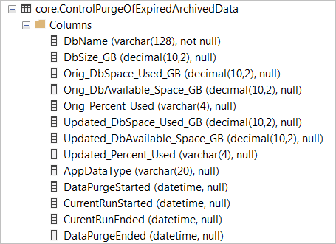

Sample data from ControlPurgeOfExpiredArchivedData table



When next purging cycle starts data from ControlPurgeOfExpiredArchivedData is moved into ControlPurgeOfExpiredArchivedData_History table to keep a history of purging cycles.

1. Purge Cycle Processing Control Table.

For each new purging cycle it is templated from the configuration table DataArchivingAndPurgingConfig which contains a list of tables on-boarded for data purging.

Each on-boarded table must be added to the purging stored procedure to enable it for processing.

Expired data from each on-boarded table will be purged based on retention days from the configuration table, one table at a time: value for column RowsToPurge will be calculated and purge of configured batch size starts and ends when updated value in column RowsPurged matches RowsToPurge.

RowsPurged is updated only after each committed batch of data was purged.

If a purge process run is interrupted its purge cycle will continue from a point of interruption once it gets restarted navigating to the point when it left off using data from the Master Control Table and Purge Cycle Processing Control Table.

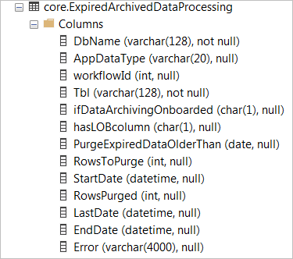

Sample data from ExpiredArchivedDataProcessing table

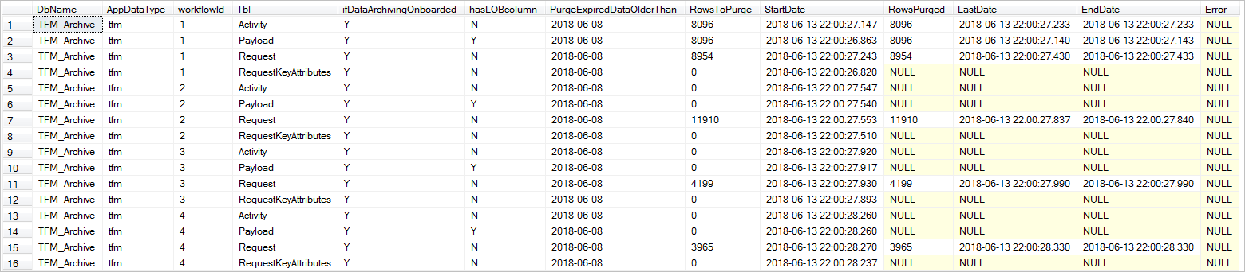

When next purging cycle starts data from ExpiredArchivedDataProcessing is moved into ExpiredArchivedDataProcessing_History table to keep a history of purging cycles.

A row with a value in column Error from ExpiredArchivedDataProcessing is also moves into its history table if purging cycle was not completed and when it restarts.

1. Configuration Table DataArchivingAndPurgingConfig

Contains a list of workflow and cross workflow tables for data archiving and data purging.

Column RetentionDays contains retention in days for source database data, column RetentionDaysForArchiving – retention for the archived data in the archival database,

column ArchivingBatchSize contains a batch size for data archiving and purging.

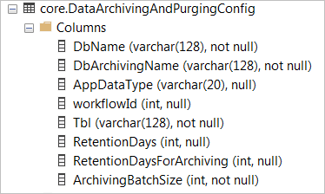

Sample data from DataArchivingAndPurgingConfig table

